**Ques #1 Print Hello World**

using System;

namespace HelloWorld

{

class Program

{

static void Main(string[] args)

{

Console.WriteLine("Hello World!");

//output prints hello world

}

}

}

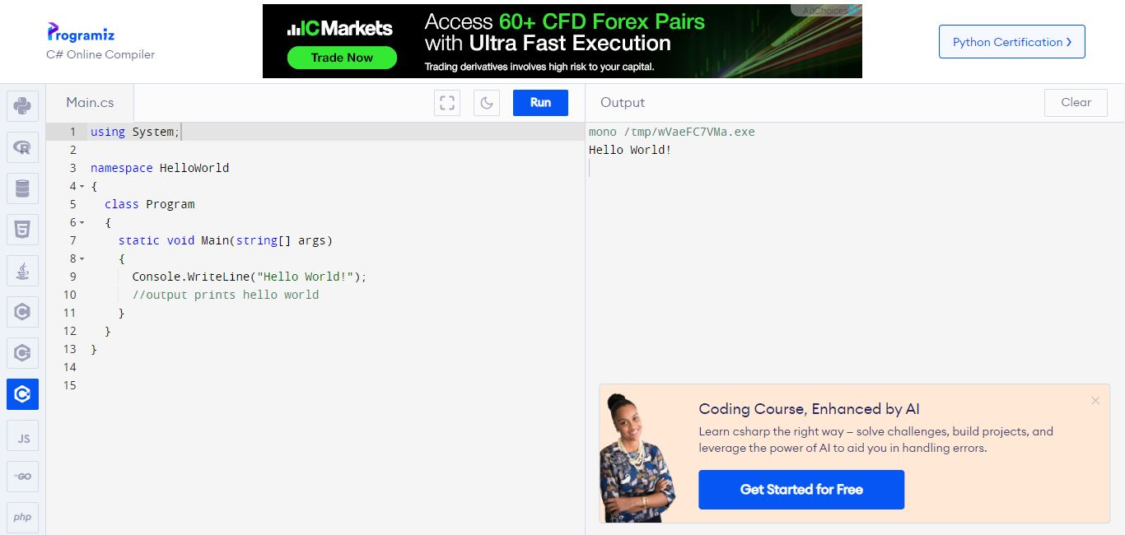

**Ques #2 A program that asks user for name and greets them with hello (name).**

using System;

class Program

{

static void Main()

{

// This will ask user their name

Console.Write("Please enter your name:");

//This will read the name from the user input

string name = Console.ReadLine();

// This will Greet the user with Hello + their name

Console.WriteLine("Hello, " + name + " Welcome");

}

}

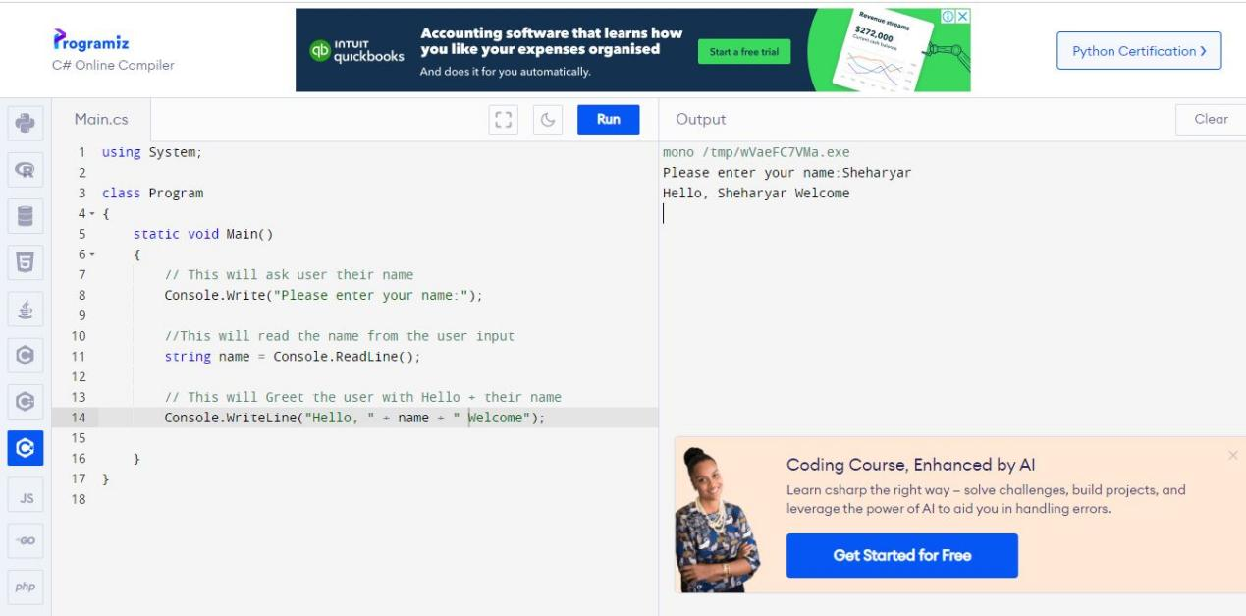

**3. Write a program that takes two numbers as input and prints their sum**

using System;

class Program

{

static void Main()

{

Console.Write("Enter the first number: ");

int number1 = int.Parse(Console.ReadLine());

// int.Parse is used to convert the string to integer

Console.Write("Enter the second number: ");

int number2 = int.Parse(Console.ReadLine());

int sum = number1 + number2;

Console.WriteLine("The sum of " + number1 + " and " + number2 + " is: " + sum);

}

}

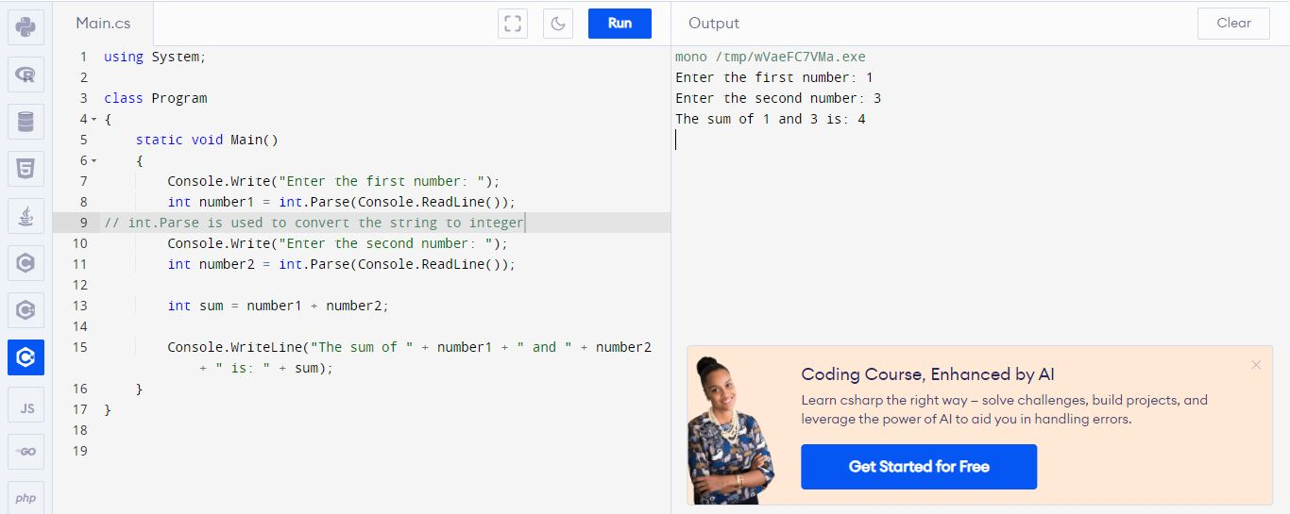

**4.Write a program that takes a number as input and prints its square**

using System;

class Program

{

static void Main()

{

Console.Write("Enter a number: ");

// convert num to int

int number = int.Parse(Console.ReadLine());

// Calculate square of the num

int square = number * number;

// Print the square

Console.WriteLine("The square of " + number + " is: " + square);

}

}

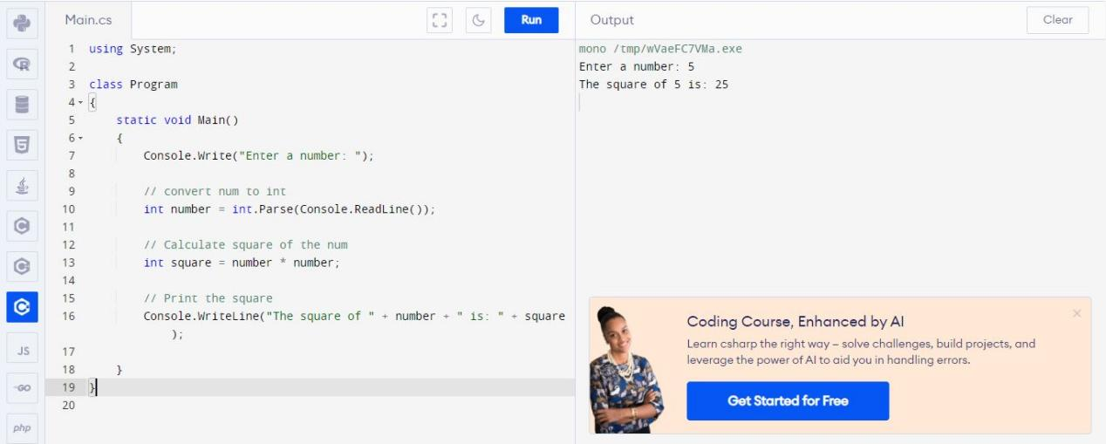

**5. Write a program that prints all even numbers from 1 to 100.**

using System;

class Program

{

static void Main()

{

Console.WriteLine("Even numbers 1 to 100:");

// apply for loop to count numbers from 1 to 100

for (int i = 1; i <= 100; i++)

{

// Checking if the number is even or not

if (i % 2 == 0)

{

// Printing even number

Console.WriteLine(i);

}

}

}

}

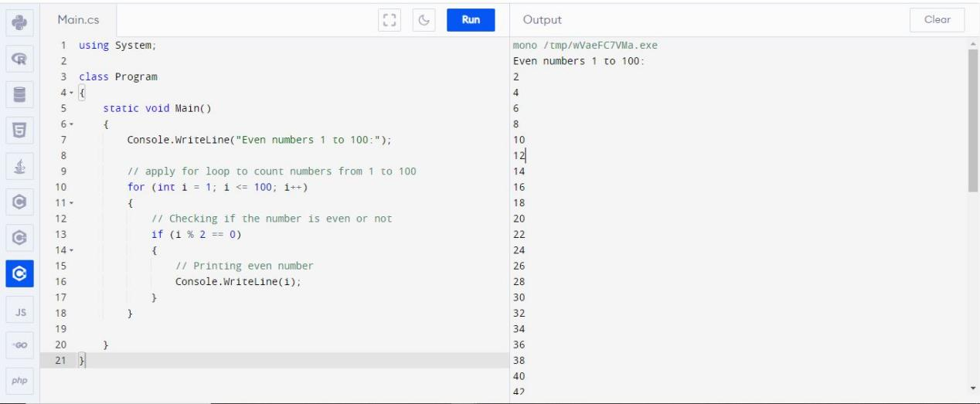

**6. Write a program that asks the user for a number n and prints the sum of the numbers**

**1 to n.**

using System;

class Program

{

static void Main()

{

Console.Write("Enter a number (n): ");

// Read the number & convert it to int

int n = int.Parse(Console.ReadLine());

// Calculate the sum of numbers from 1 to n

int sum = 0;

for (int i = 1; i <= n; i++)

{

sum += i;

}

// Print sum

Console.WriteLine("The sum of numbers from 1 to " + n + " is: " + sum);

}

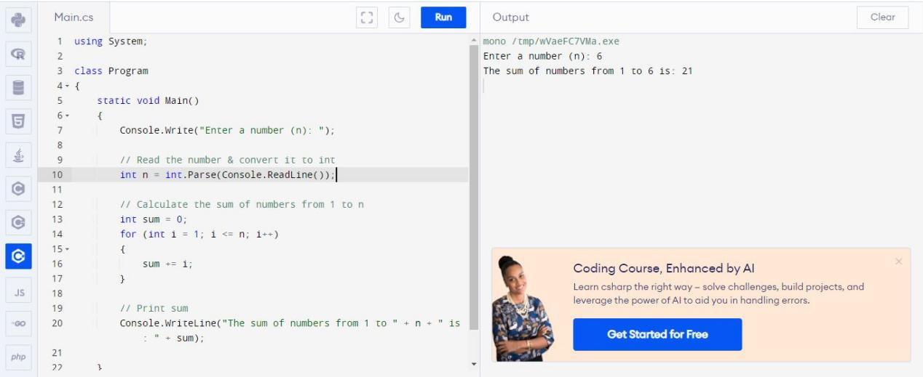

**7. Write a program that prints a multiplication table for numbers up to 12.**

using System;

class Program

{

static void Main()

{

// Loop through numbers from 1 to 12

for (int i = 1; i <= 12; i++)

{

// multiplication table for number now

for (int m = 1; m <= 12; m++)

{

int result = i * m;

Console.Write(result + new string(' ', 5 - result.ToString().Length));

}

Console.WriteLine();

}

}

}

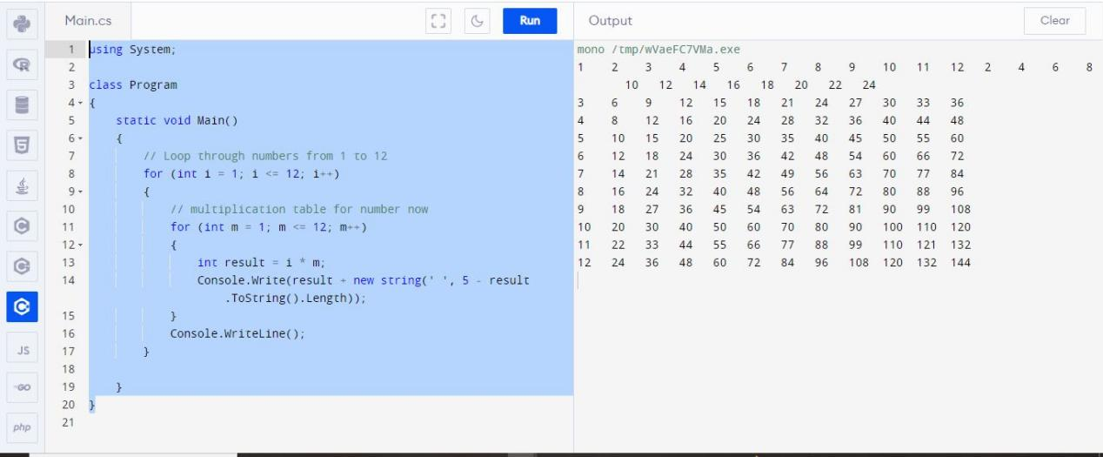

**8. Write a program that prints all prime numbers up to n (where n is user input).**

using System;

class Program

{

static void Main()

{

Console.Write("Enter a number (n): ");

int n = int.Parse(Console.ReadLine());

Console.WriteLine("Prime numbers up to " + n + ":");

for (int i = 2; i <= n; i++)

{

bool isPrime = true;

for (int j = 2; j <= Math.Sqrt(i); j++)

{

if (i % j == 0)

{

isPrime = false;

break;

}

}

if (isPrime)

{

Console.WriteLine(i);

}

}

}

}

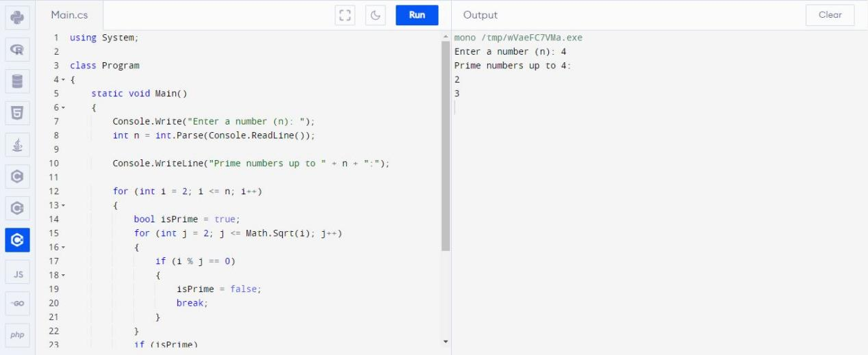

**9. Write a program that computes the factorial of a number (n!).**

using System;

class Program

{

static void Main()

{

Console.Write("Enter a number (num): ");

int num = int.Parse(Console.ReadLine());

// Calculate the factorial

long factorial = 1;

for (int i = 1; i <= num; i++)

{

factorial *= i;

}

// Print the factorial

Console.WriteLine("The factorial of " + num + " is: " + factorial);

}

}

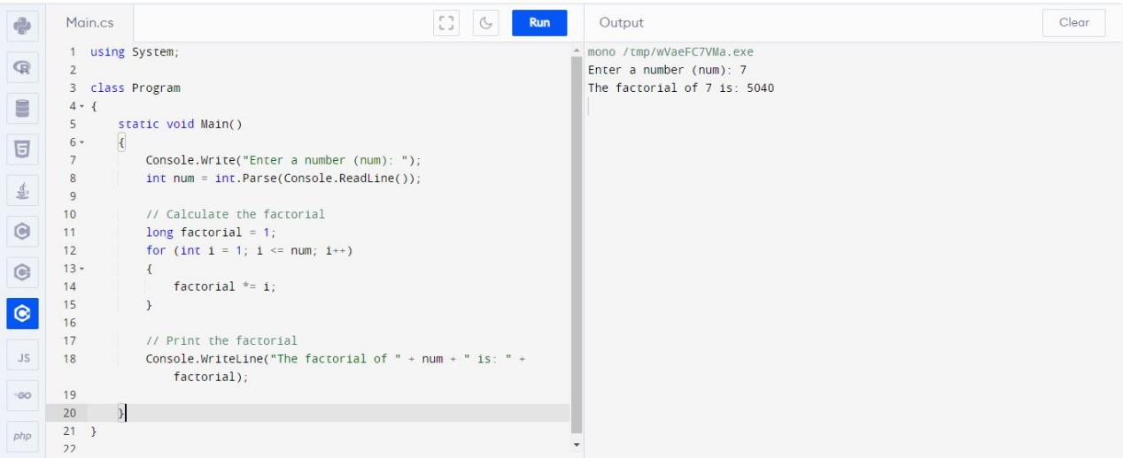

**10. Write a program that prints the Fibonacci sequence up to n terms (where n is user input).**

using System;

class Program

{

static void Main()

{

Console.Write("Enter the number of terms in Fibonacci sequence (num): ");

int num = int.Parse(Console.ReadLine());

int firstTerm = 0, secondTerm = 1;

Console.WriteLine("Fibonacci sequence up to " + num + " terms:");

for (int i = 1; i <= num; i++)

{

Console.Write(firstTerm + " ");

int nextTerm = firstTerm + secondTerm;

firstTerm = secondTerm;

secondTerm = nextTerm;

}

}

